

Test Plan

OutSports

An application to facilitate the safe practice of sports in a group.

Software engineering 2020-2021

Erasmus Group:

Inês Santos 884840

Nuno Nogueira 884842

Rui Ramos 884843

Index

1 Overview 3

1.1 Purpose 3

1.2 Project Deliverables 3

2 Testing Summary 3

2.1 Scope of Testing 3

2.1.1 Scope of Testing 3

2.1.2 Organizational structure 3

3 Analysis of Scope and Test Focus Areas 4

3.1 Release Content 4

3.2 Assumptions, Dependencies and Constraints 4

3.3 Platform Testing 4

4 Progression Test Objectives 5

5 Other Testing 8

5.1 Unit Testing 8

5.2 Integration Testing 8

6 Test Strategy 9

6.1 Test Type & Approach 9

6.2 Build strategy 10

6.3 Facility, data, and resource provision plan 10

6.3.1 Access to other applications 10

6.3.2 Testing Requirements 10

6.3.3 Resources & Skills 10

6.4 Testing Tools 11

7 Test Environment Plan 11

7.1 Test Type & Approach 11

7.2 Test Environment Details 12

7.2.1 Testers 12

7.2.2 Hardware and Firmware 12

7.2.3 Software 12

7.3 Establishing Environment 13

7.4 Environment Roles and Responsibilities 14

8 Test Strategy 15

8.1 Test Milestones and Schedule 15

9 Definitions 16

10 References 16

# Overview

## Purpose

The purpose of this document is to help us to think about all the tests we have to do to the app as well as the test schedule and major milestones.

## Project Deliverables

The scope of this document is to detail all the tests that we will be performed by our project team. The test plan defines what we will test, how testing will be performed as well as what resources we will need.

# Testing Summary

## Scope of Testing

## Scope of Testing

Our in scope testing includes system integration and the test to every feature and correction to any bugs found.

## Organizational structure

Some out of scope testing issues we can come across are:

Problems related to smart filters or virus scanners, e.g. blocking the execution of apps.

Setup problems in tests.

# Analysis of Scope and Test Focus Areas

## Release Content

Content to be released:

* Client local account that contains the data of all their activities. The saved data would correspond to the number of km made in a trail that can be viewed in a map and the average speed made by the client.
* Whenever the users want to perform a group activity, there are the features that allow them to make a “team” in this mode they can:
  + Know the location of all team members in real-time on a map.
  + Click on a user in their team and view information such their distance to the user.
  + Whenever someone is stopped for more than x minutes a notification will be sent to every team member (toggle function).
  + If someone from the team gets separated the last known coordinates will be sent to every person in the group (toggle function).

For further information please consult the Analysis and specification document.

## Assumptions, Dependencies and Constraints

As we cannot test the p2p connection in person due to the COVID situation we were instructed to assume that the users were all together, to do that we simulated their coordinates, speed, and routes in order to properly test the app.

## Platform Testing

For testing we will be using the software “android studio” emulating an android system (Android smartphone with the version 7.0 and above), this software will be run on windows 10 on each of our personal computers.

# Progression Test Objectives

|  |  |  |  |  |  |
| --- | --- | --- | --- | --- | --- |
| Ref | Function | Test Objective | Evaluation Criteria | X-Ref | P |
| Client local account | | | | | |
| REF00 | Create local client account | Create local client account that is not lost once the client exits the app | ·        Account is created with success  ·        User closes and opens the app the data saved on the account is not lost | - | High |
| REF01 | Change local accounts data | Users can change simple data such as name, age, etc. | ·        User changes information with success  ·        User closes and opens the app and the data changed remains changed | - | Medium |
| REF02 | Recording of activities done | After an activity, details will need to be saved in the user’s account | ·        User ends a stared activity and details such as km, speed and trail made are recorded in the user’s account | - | High |
| REF03 | Visualization of recorded activity on the map | Users need to be able to see on a map his past activities | ·        The activity previously recorded is shown on the map in an accurate fashion | REF02 | Medium |

|  |  |  |  |  |  |
| --- | --- | --- | --- | --- | --- |
| Activity features | | | | | |
| REF04 | Track exercise | Tracking and monitoring activity until the end of the exercise | ·        User starts the activity with success  ·        Monitoring of speed and location are working properly | - | High |
| REF05 | End activity | End an activity started | ·        The user ends an activity that is in progress and the data is saved to his local account | - | High |
| REF06 | View location on the map | During an activity, the user can use the map to track his location | ·        User shown on the map  ·        Location is updated when they move | - | High |

|  |  |  |  |  |  |
| --- | --- | --- | --- | --- | --- |
| Group Features | | | | | |
| REF07 | Join a group | The user can find and join a group in his vicinity | ·        App detected open groups in the vicinity of the user  ·        User can join the group of his choosing successfully | - | High |
| REF08 | Track an activity while in a group | Tracking and monitoring activity until the end of the exercise whilst in a group | ·        User starts the activity with success  ·        Monitoring of speed and location are working properly | REF06 | High |

|  |  |  |  |  |  |
| --- | --- | --- | --- | --- | --- |
| Group Features | | | | | |
| REF09 | Leave the group | User can leave the group at a time of his choosing | ·        User leaves the group without affecting the other team members  ·        His activity ends and is saved to his account | REF06 | High |
| REF10 | Make a group | A user not in a group needs to be able to make a group | ·        User makes a group that allows other users to join  ·        User gets the status of team leader | - | High |
| REF11 | Add teammate | The team leader is able to add a teammate if the other user is close enough | ·        User can add a teammate if the other user is close enough | REF09 | High |
| REF12 | Expel teammate | The team leader can expel a teammate | ·        User can expel a teammate without disturbing the rest of the team and the tracking of the exercise | REF09 | High |
| REF13 | View teammate account | Any person in the group can view their distance between the user and the person selected | ·        Clicking in a teammate profile  ·        Being able to see is information | REF09 or REF06 | Medium |
| REF14 | View teammate on the map | During a group activity, the user always needs to be able to see his teammates current location | ·        Teammates show on the map  ·        Location is updated when they move | REF09 or REF06 | High |

# Other Testing

## Unit Testing

The unit testing will be done by the group member who developed that unit because they more than anyone will have the knowledge to test the unit properly.

The units being tested are:

* Client local account
* Activity features
* Group Features

## Integration Testing

The only integration testing that will need to be done is on the google maps application, that is used to draw the route and tracking of the elements of the group or the single user position.

# Test Strategy

## Test Type & Approach

As testing strategies, we found it appropriate to use:

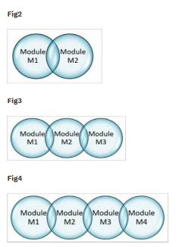**Incremental testing:** This type of testing divides the code that is developed and needs to be tested into modules once a module is fully tested is combined incrementally with the other modules, this assures that all code works together.

We plan to implement this kind of testing every time we develop a new class to make sure it all works seamlessly with the other classes already developed.

**Black-Box Testing:** Black box testing is done by providing different inputs (valid and invalid) and then seeing if the program responds as expected. This is very useful to test the program on a basic level to find common errors that a user without application knowledge could find.

This type of testing will be done towards the end of the development when the code is mostly done and we’ll start testing for easy bugs that a user might find just by putting the wrong input.

## Build strategy

We plan to have an all-in-one installation process, because it facilitates the user’s experience, and we don't find it necessary since our app is not big or complex enough to need being broken up into smaller pieces and then put together.

## Facility, data, and resource provision plan

## Access to other applications

During the testing phase we will need access to:

* The google maps server for functionality related to the map features.

## Testing Requirements

Each person involved in testing will need the following access:

* Access to a personal computer.
* Access to the software android studio.
* Access to google maps server.

## Resources & Skills

Resources and skills required during the testing window:

* A resource with java skill.
* Android studio knowledge;

## Testing Tools

The following tools will be used for testing:

|  |  |
| --- | --- |
| Process | Tool |
| Test case execution | Manual |
| Test software | Android  Studio |
| Test hardware | Personal computer with an Android emulator |

# Test Environment Plan

## Test Type & Approach

Test Environment diagram:

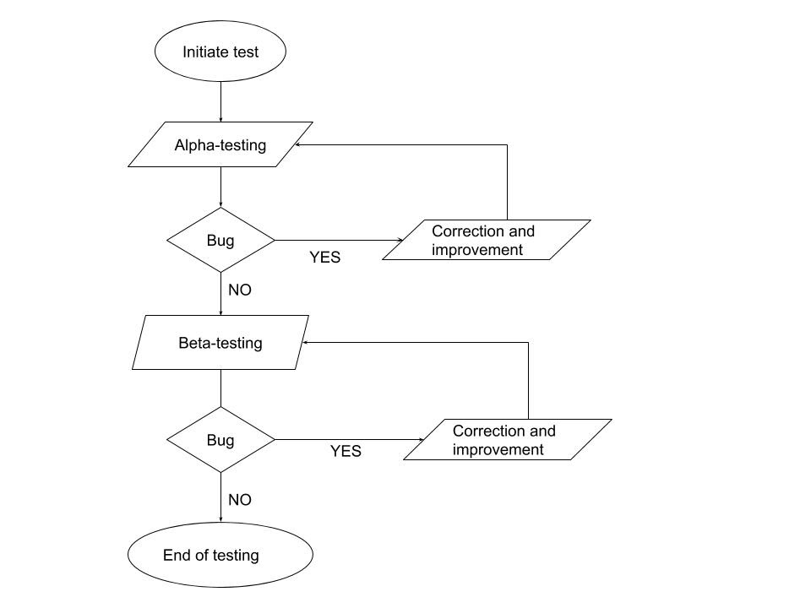

## Test Environment Details

## Testers

The testers will be the three members of the group (Inês Santos, Nuno Nogueira, Rui Ramos).

## Hardware and Firmware

Personal computer using android studio emulator.

## Software

Emulator smartphone with Android operating system equal to or higher than the version 8.0

Google Play services version 20.42.0 or higher

Android device emulator (available natively on Android Studio)

## Establishing Environment

Define the plan for establishing the testing environment, and responsibilities. This should include acquisition of each element, setup, installation and testing the environment.

|  |  |  |  |
| --- | --- | --- | --- |
| Task | Responsibility | Start Date | End Date |
| Create local client account | Rui Ramos | 15/11/2020 | 18/11/2020 |
| Change local accounts data | Rui Ramos | 18/11/2020 | 21/11/2020 |
| Recording of activities done | Nuno Nogueira | 27/11/2020 | 2/12/2020 |
| Visualization of recorded activity details and on the map | Nuno Nogueira | 2/12/2020 | 5/12/2020 |
| Track exercise | Nuno Nogueira | 16/11/2020 | 26/11/2020 |
| End activity | Nuno Nogueira | 16/11/2020 | 26/11/2020 |
| View location on the map | Nuno Nogueira | 16/11/2020 | 26/11/2020 |
| Make a group | Inês Santos | 19/11/2020 | 24/11/2020 |
| Track an activity while in a group | Nuno Nogueira | 24/11/2020 | 1/12/2020 |
| Join a group | Inês Santos | 24/11/2020 | 27/11/2020 |

|  |  |  |  |
| --- | --- | --- | --- |
| Task | Responsibility | Start Date | End Date |
| Add teammate | Inês Santos | 27/11/2020 | 30/11/2020 |
| Leave the group | Inês Santos | 30/11/2020 | 4/12/2020 |
| Expel teammate | Inês Santos | 4/12/2020 | 8/12/2020 |
| View teammate account | Rui Ramos | 8/12/2020 | 12/12/2020 |
| View teammate on the map | Rui Ramos | 12/12/2020 | 17/12/2020 |

## Environment Roles and Responsibilities

Due to the fact that this is a small project with only three people working on it, several roles and responsibilities will be shared.

Regarding testing, all three of us will have shared responsibilities, with those being:

- Test Coordination;

- Support of the testing environment

# Test Strategy

## Test Milestones and Schedule

Detailed below are the high-level testing milestones.

|  |  |  |  |
| --- | --- | --- | --- |
| Milestone | Planned End Date | Actual End Date | Resource |
| Alpha testing start | 19/12/2020 | - | * A resource with java skill * Android studio knowledge * FireBase knowledge |
| Alpha testing end | 15/01/2021 | - | * A resource with java skill * Android studio knowledge * FireBase knowledge |
| Beta testing start | 30/11/2020 | - | * A resource with java skill * Android studio knowledge * FireBase knowledge |
| Beta testing end | 18/12/2020 | - | * A resource with java skill * Android studio knowledge * FireBase knowledge |
| Release the project to the public | 15/01/2020 | - | - |

As of this phase of the project, we are not yet on testing so it is impossible to say the “actual end date”.

# Definitions

The following acronyms and terms have been used throughout this document

|  |  |
| --- | --- |
| **Term/Acronym** | **Definition** |
| Android | Android is an operating system for mobile devices developed by Google |
| Android Studio | Android Studio is an integrated development environment(IDE) for development for the Android platform |
| Bug | Error in writing the source code that leads to anomalous behaviour of the software; |
| Alpha | Alpha is the version of the software under development whose functionality has not yet been fully implemented, often these versions are affected by bugs. |
| Beta | The non-definitive version of a software, still being tested. |
| App | Short for application, or software program intended for an end-user. The term is usually used with reference to mobile terminals. |
| Java | High-level object-oriented programming language. |

# References

The following documents have been used to assist in the creation of this document.

|  |  |
| --- | --- |
| **#** | **Document name** |
| 1 | https://www.guru99.com/what-is-security-testing.html#2 |
| 2 | https://www.softwaretestinghelp.com/incremental-testing/ |
| 3 | https://www.guru99.com/thread-testing.html |